**Project Details**

**IBM Cognos Powered HR and People Analytics Dashboard**

**Student Name:** **Debadrito Saha**

**Institute Name:** **Symbiosis Institute of Business Management, Pune**

**SmartInternz Email Credentials:** [**SI2021IBMPB00166@smartinternz.com**](mailto:SI2021IBMPB00166@smartinternz.com)

**Personal Email id:** **debadrito.saha.mba22@associates.sibmpune.edu.in**

**Project Objectives:**

* Know fundamental concepts and can work on IBM Cognos Analytics.
* Gain a broad understanding of plotting different graphs.
* Able to create meaningful dashboards

**Project Flow:**

* IBM Cloud Account
* Log in to Cognos Analytics
* Working with the Dataset
  + Understand the Dataset
  + Loading the Dataset
* Data visualization charts

**Project Details**

**IBM Cloud Account:**

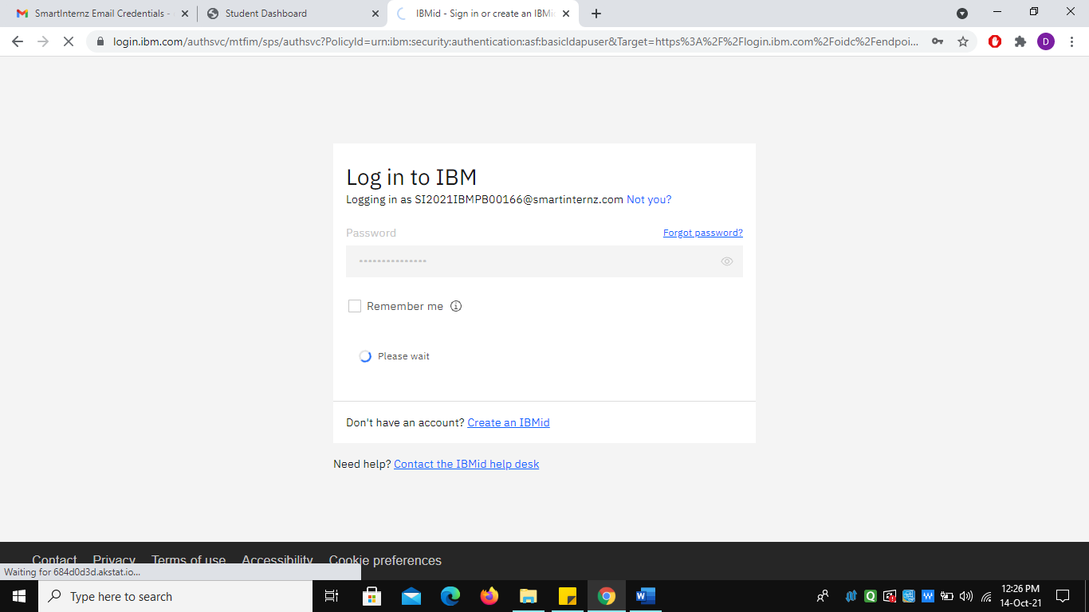

Logging into Cognos Analytics:

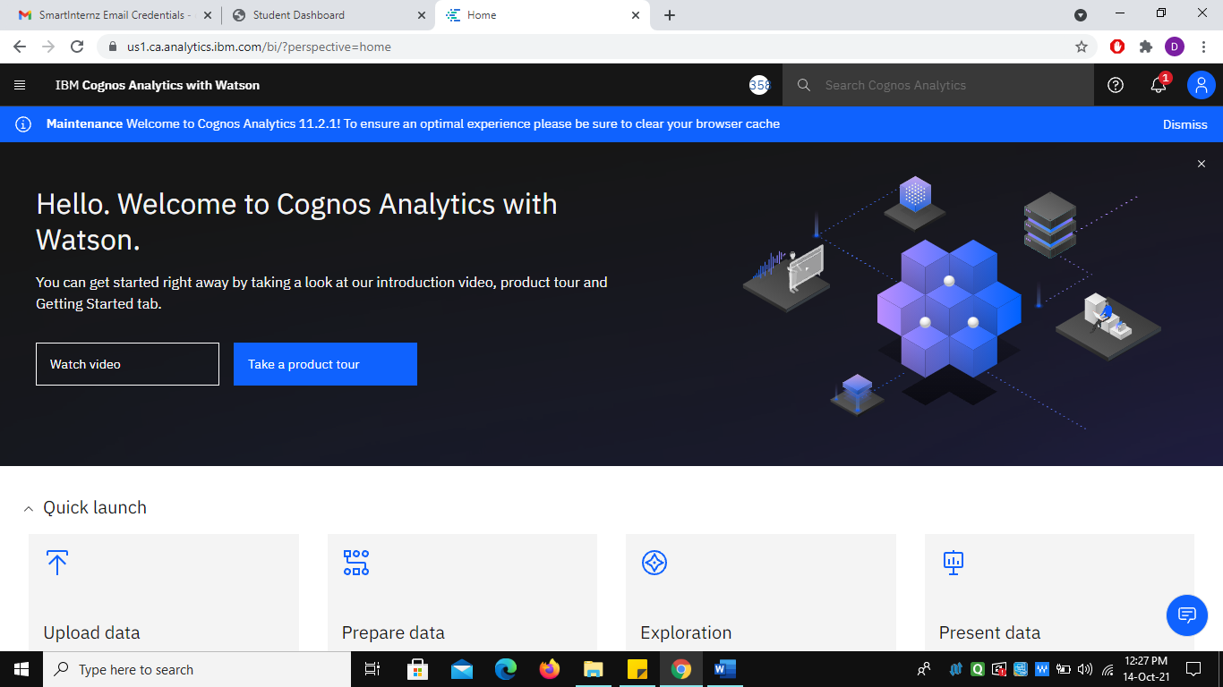

**Working with the dataset:**

The dataset is present at

<https://www.kaggle.com/pavansubhasht/ibm-hr-analytics-attrition-dataset>

**Data Visualization Charts:**

Various Data Visualization Charts are as follows.

1. Analysing Age, Total Working Years, Attrition, Years At Company and Monthly Income

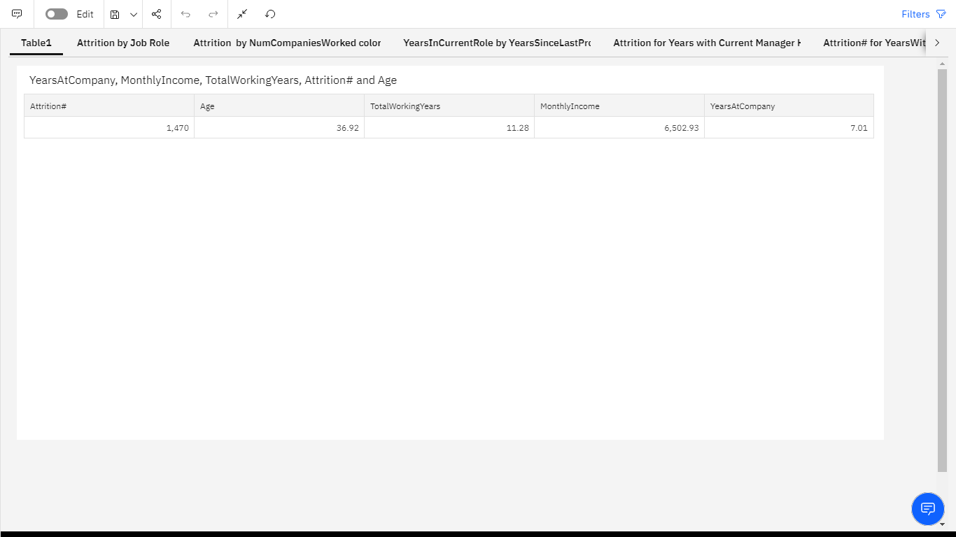

2. Analyzing of Attrition by Job Role

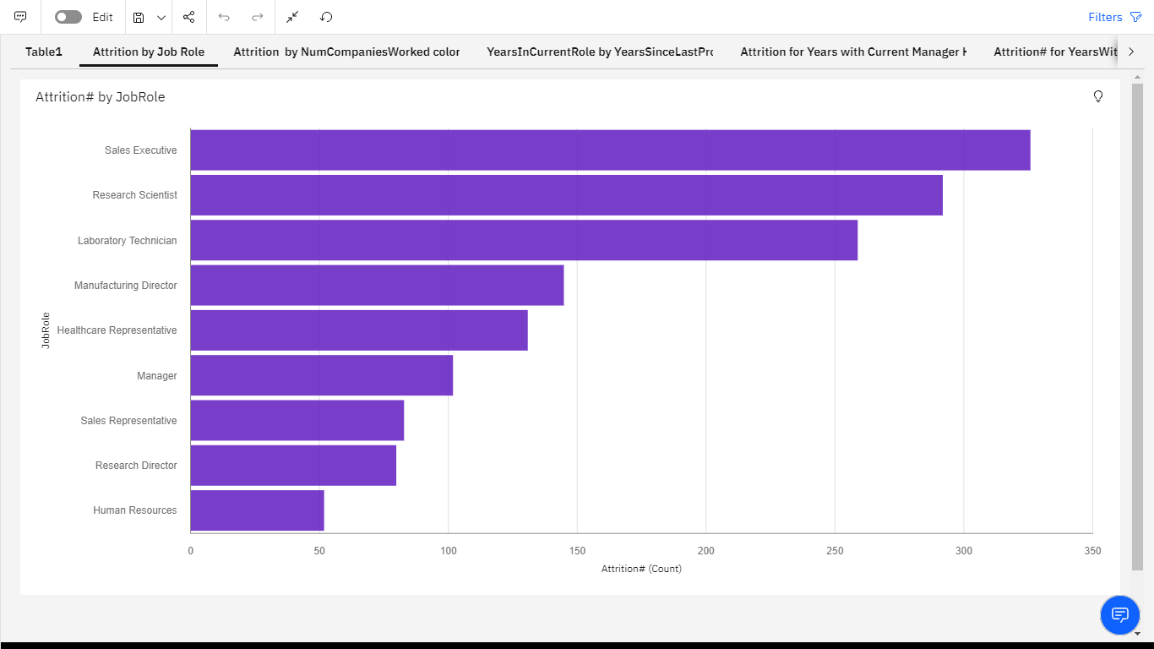

3. Attrition by number of companies worked colored by Job Role

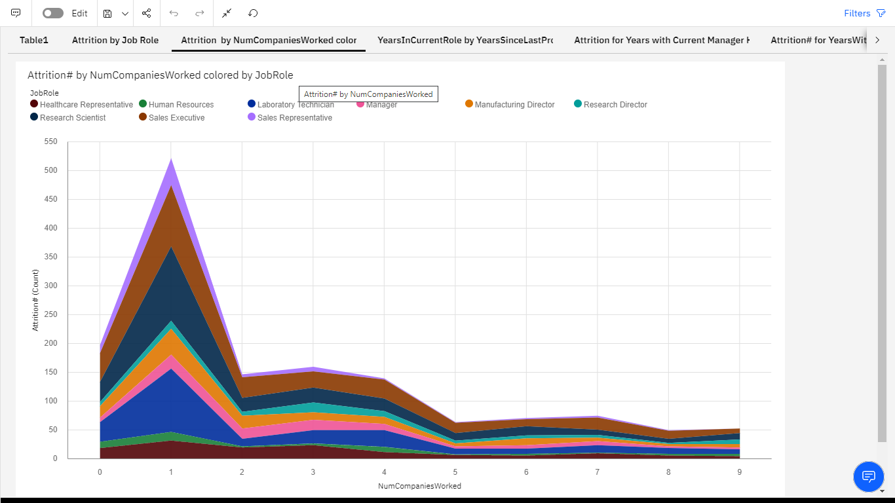

4. Years In Current Role by Years since last promotion colored by Attrition

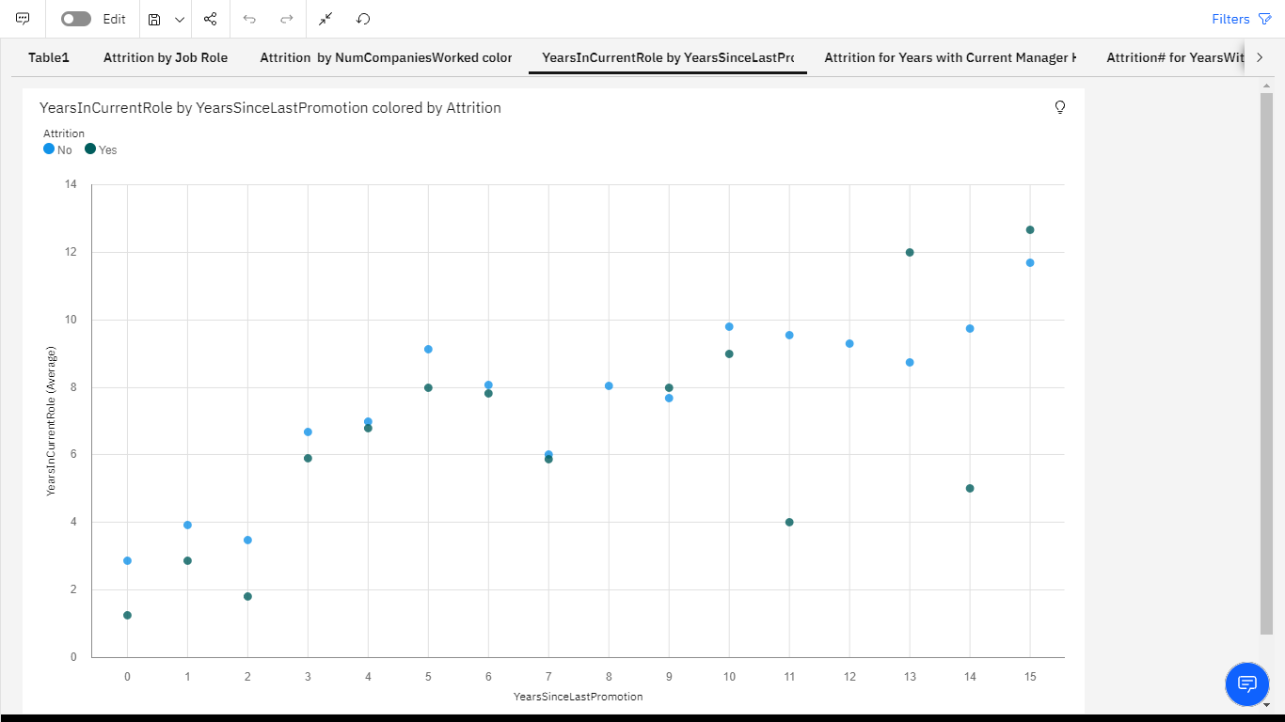

5. Attrition for Years with Current Manager Hierarchy

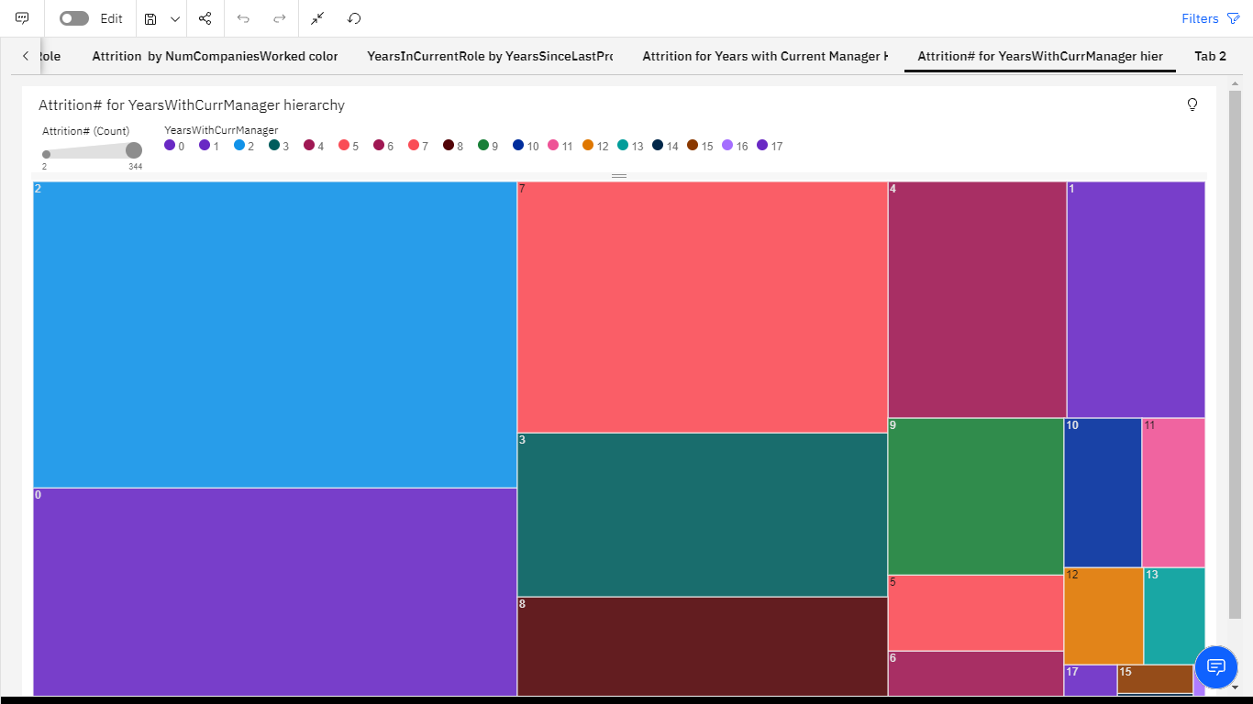

6. Final dashboard

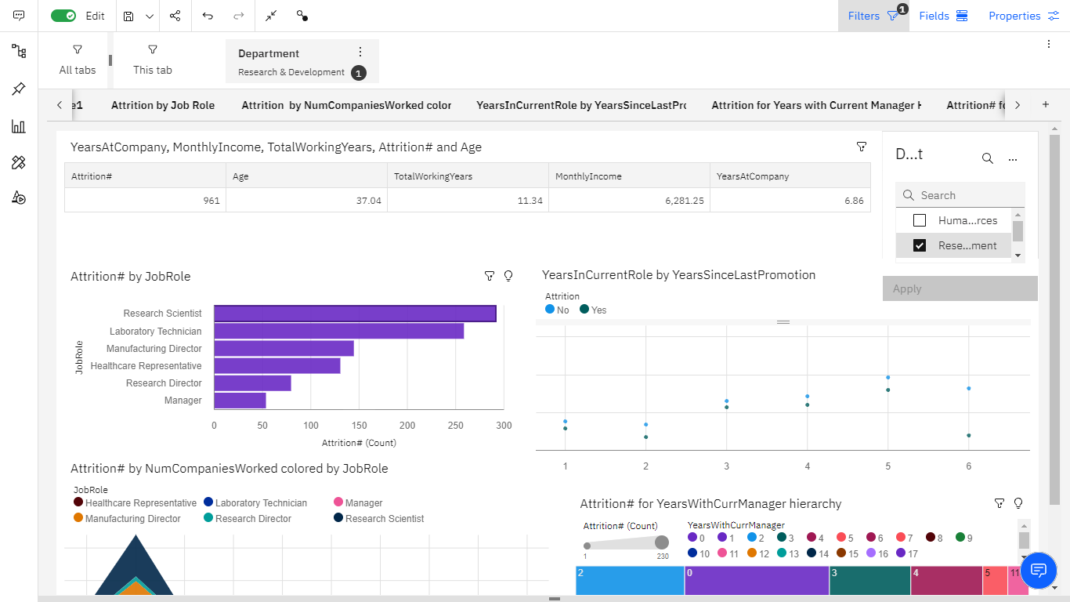

**Conclusion:** IBM Cognos Analytics is an integrated business intelligence suite by IBM. It provides a toolset for reporting, analytics, score carding, and monitoring of events and metrics. The software consists of several components designed to meet the different information requirements. It is extremely useful for data visualization and modelling.

Here, in this assignment, IBM Cognos Analytics is leveraged to get insights about various HR parameters in an organization with the help of different types of charts.